Angelica Idoko

Marc Temkin

Game Engine Scripting

October 8, 2020

Game Design Document

# Game Title: Red World

## Genre: 2D Top down shooter

## Mode(s): Single-player

## **Other Similar Games:**

**Hotline Miami (The first One)**

* Hotline miami is a 2D top down shooter that follows the player character named “jacket” as he goes on a rampage in Miami. The games have similar themes on violence and its effects on the environment and people around them.

[Hotline Miami Collection - Official Trailer (IGN)](https://youtu.be/Qtl2fG-_l9M)

**Concept:**

The concept of this game came from reading a wiki of Hotline Miami as well as watching a youtube video explaining its story. Red world follows a silent unnamed protagonist who is pursuing an entity rumored and given the name “Gash”.

**Controls:**

W - Up

S - Down

A - Left

D - Right

E - Shoot

Q - Inventory

R - Menu

*Alternative:*

Up Arrow

Down Arrow

Left Arrow

Right Arrow

*Alternative:*

I - Shoot

O - Inventory

P - Menu

**Walkthrough:**

Players are tasked with killing all enemies off the field when they start the game. At the start they will not be given a weapon but will have to look throughout the map finding any weapons laying around and eliminate enemies without getting killed themselves.

**Art references:**

My plan was to make the assets myself (but that could change).

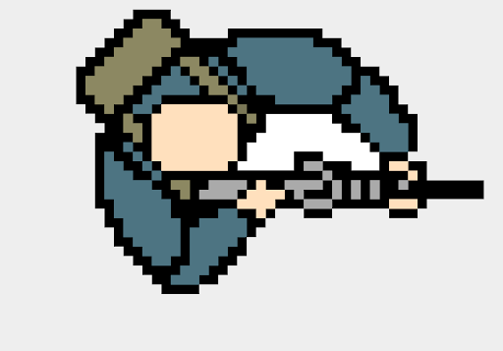

**Picture Site Link:** http://pixelartmaker.com/art/cfe4977e16cae14